

SMARTCAMPUS LOGISTIC & HOSPITALITY
FUTURE DIGITAL CAMPUS

TECHNOLOGY & INFORMATION SYSTEM
SECP1513-08
DR. SHAFAATUNNUR BINTI HASAN

TEAM MEMBERS:
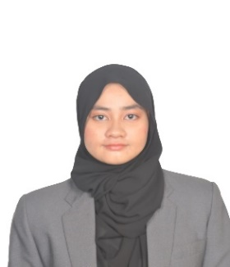
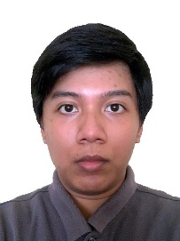
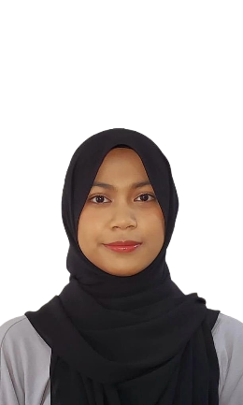

WT NURUL AZWA SAFIRA BT WT MOHD AZRUL  A25CS0378 | MOHAMAD NASRIN BIN MOHD YUSOFF  A23CS3012 | MUHAMMAD SYAHMIL AMRI BIN HASLIN  A25CS0283 | NURALYA SOFEA BINTI ASHA'RI  A25CS0325

TABLE OF CONTENTS

1.0 INTRODUCTION 3
2.0 DETAILED DESCRIPTION 4
2.1 PROBLEM 4
2.2 SOLUTION 4
2.3 TEAM WORKING 5
3.0 DESGIN THINKING ASSESMENT 6
4.0 DESIGN THINKING EVIDENCE 7
4.1 EMPATHY 7-9
4.2 DEFINE 10
4.3 IDEATE 10
4.4 PROTOTYPE 11-18
4.5 TEST 19
5.0 REFLECTIONS 21

1.0 INTRODUCTION

Universities often have large and complex campus landscapes consisting of multiple faculties, administrative buildings, roads, parking areas, and transportation systems. While these facilities are designed to support academic and social activities, they can become confusing and overwhelming for users who are unfamiliar with the campus environment. New students, visitors and parents frequently face difficulties navigating the campus, locating buildings, estimating transportation arrival times, and finding available parking spaces.
These challenges negatively impact the overall campus experience, causing stress, wasted time, and inefficiency. Therefore, the general goal of this project is to enhance the campus-related experience by applying the Design Thinking approach to identify user problems and develop a practical, user-centred solution. Through empathy, problem definition, ideation, prototyping, and testing, this project aims to create a digital solution that improves campus navigation, transportation reliability, and parking accessibility.

2.0 DETAILED DESCRIPTIONS

2.1 PROBLEM

- Who is affected
The stated problem that our project revolves around primarily affects new students and visitors.

- Where the problem occurs
The issues often occur across the entire university campus, including faculty buildings and lecture halls, bus stops and transportation routes, and parking areas.

- Why the problem exists
The large and complex campus layout makes navigation difficult, especially for new users, while existing maps are static and unclear. Unreliable bus arrival times cause long waits or missed buses, and the lack of accessible parking availability information leads to circling, congestion, and wasted time.

2.2 SOLUTION

The proposed SmartCampus Logistic and Hospitality (Logistic and Visitor) system is a digital campus assistance platform with the following features:

- Orientation and Navigation
Provides an interactive campus map with location search and step-by-step navigation to help users easily find faculties, lecture halls, offices, libraries, and other facilities.

- Campus Bus System
Offers real-time bus tracking, arrival estimates, and clear route and stop information to reduce waiting time and improve campus transportation.

- Parking Assistance
Displays real-time parking availability and guides users to nearby vacant spaces, saving time and reducing traffic congestion.

2.3 TEAM WORKING

This project was completed through continuous teamwork, where each member contributed to accomplish different tasks.

Team members: Tasks:

Muhammad Syahmil Amri bin Haslin Empathy data collection and demonstration video production

Mohamad Nasrin bin Mohd Yusoff Interface design

WT Nurul Azwa Safira binti Mohd Azrul Wireframe design

Nuralya Sofea binti Asha’ri Documentation and report writing

3.0 DESIGN THINKING ASSESSMENT

The assessment conducted at the end of the project evaluates how well the proposed solution addresses the identified problem. However, this form of assessment only served as a summative evaluation. It did not capture fully the evolution of ideas, the influence of user feedback, or the iterative refinements made during the project.
Thus, this is where assessments during transitions between Design Thinking phases become crucial. More emphasis was placed, meaning at each phase transition, progress was reviewed to ensure that decisions were grounded in user insights. Such approach enabled early identification of gaps, validated assumptions and informed decision-making.

4.0 DESIGN THINKING EVIDENCE

4.1 EMPATHY

In this phase, a survey involving empathy questions was conducted via Google Form, which was distributed among students and visitors. The data obtained are as documented:

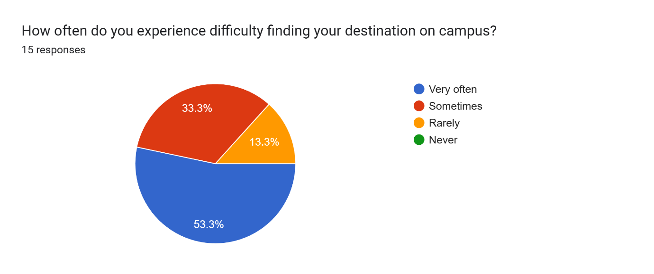

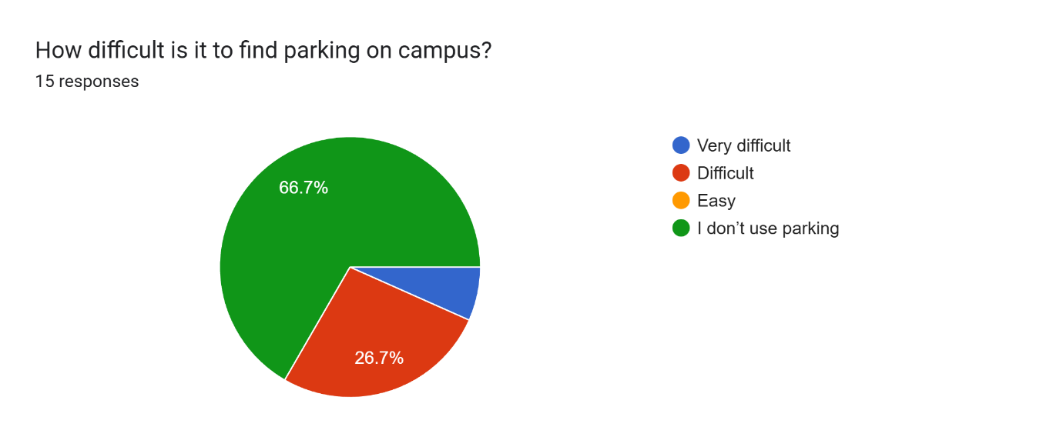
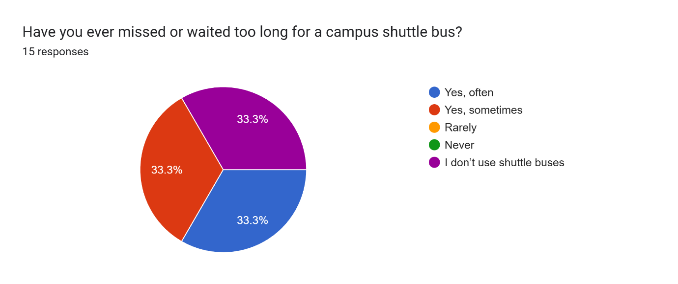

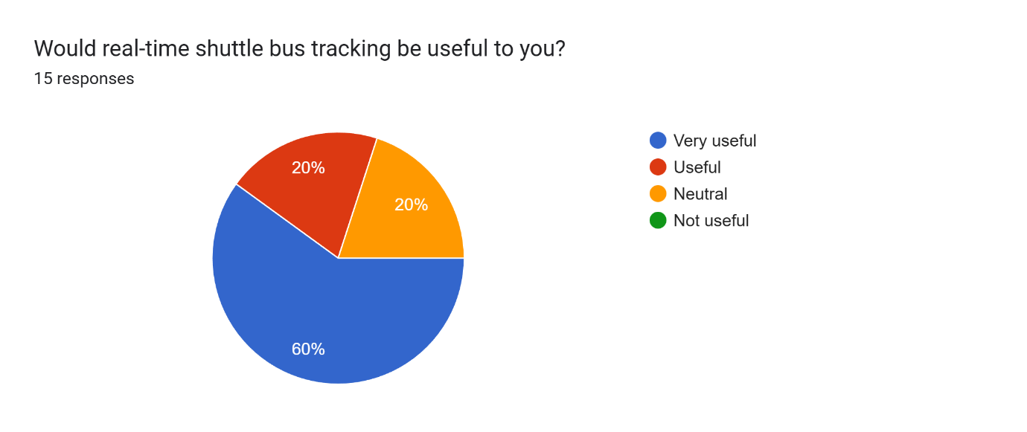

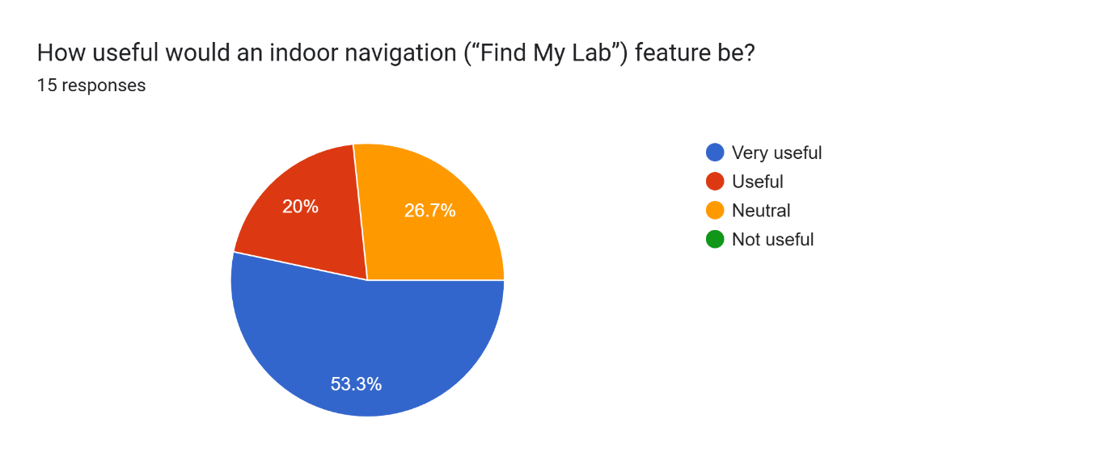
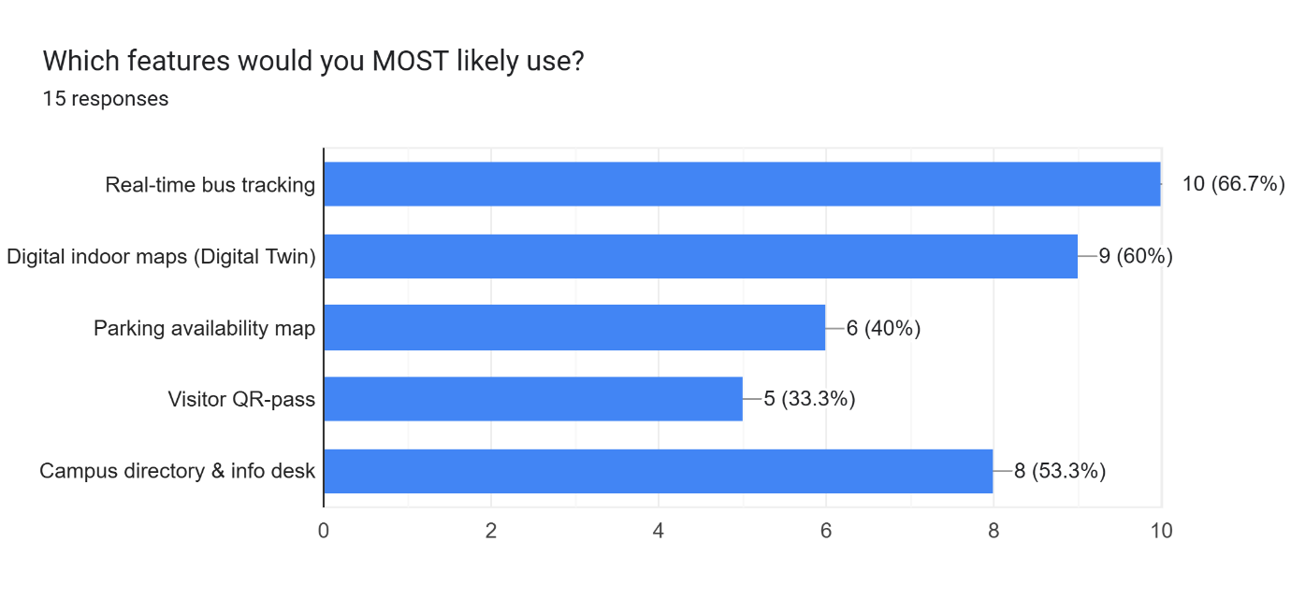

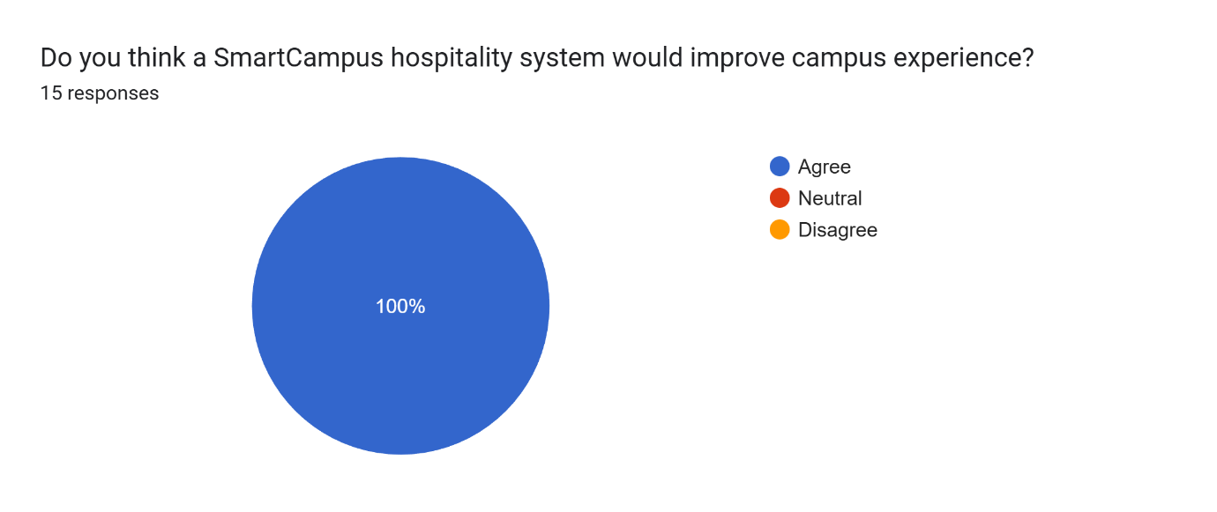

In conclusion, the empathy research revealed that students and visitors face challenges with campus navigation, parking availability, and bus scheduling. All users agreed that the SmartCampus Hospitality System would improve their overall campus experience.

4.2 DEFINE

The empathy research clearly identified key challenges faced by students and visitors, including difficulty locating academic buildings, offices, and laboratories, navigating unfamiliar areas, finding available parking, and dealing with inaccurate shuttle bus arrival times. Based on these findings, clear problem statements were developed to guide the design process. A central statement emphasized the need for a solution that supports accurate campus navigation, real-time shuttle bus updates, parking assistance, and both indoor and outdoor guidance, ensuring the proposed design directly addresses user needs and improves the overall campus experience.

4.3 IDEATE
During Ideation phase, the team brainstormed possible solutions for the defined problems. Techniques such as rapid sketching were used to generate ideas. A low-fidelity wireframe—as shown below—was created to visualize user flows and app functionality.

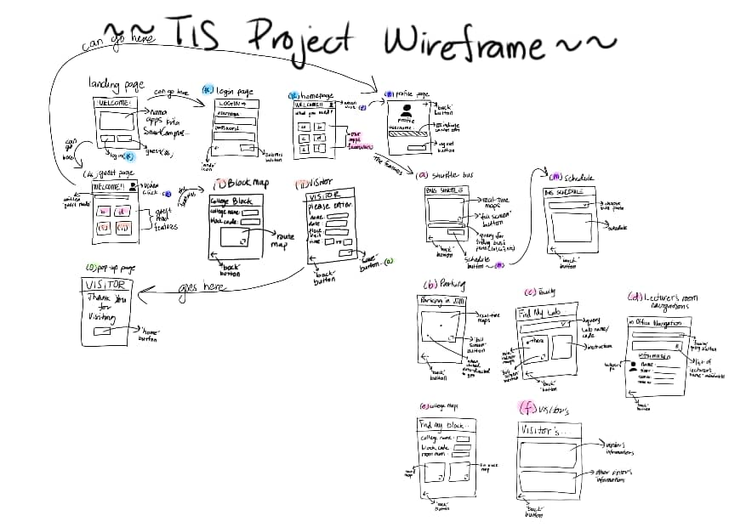

4.4 PROTOTYPE

After finalising the wireframe design, our team have designed the yet-to-be-finalised prototype (as it will be tested later) with the following functions:

User will first encounter the Welcome page, followed by the Login page where they can choose whether to login or continue as guest.
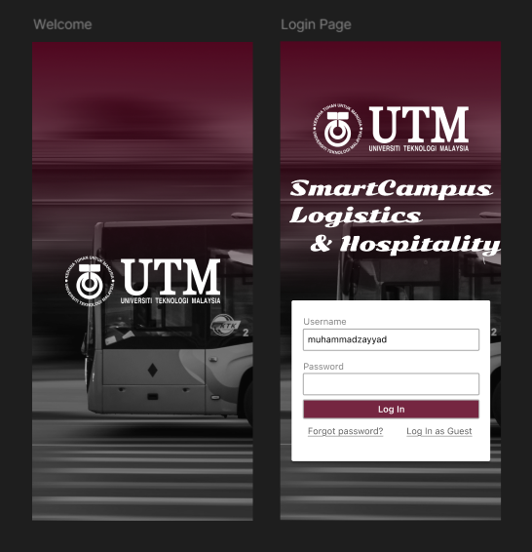

Upon choosing the guest mode, user will be directed to Guest Profile. User can choose to either login or go to Dashboard.
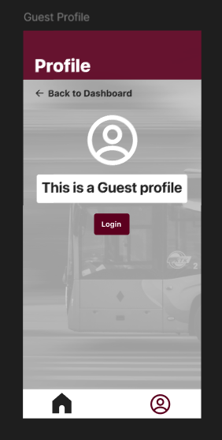

User is directed to Dashboard when clicked. Here, user can choose to either find parking, lecturers’ rooms, blocks or fill in visitor information.
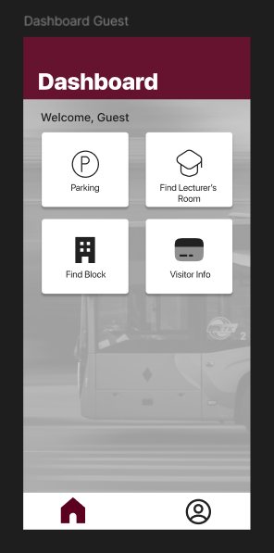

Upon choosing Parking, user will encounter the Parking page where the campus map is shown. The nearest parking spot is automatically detected.
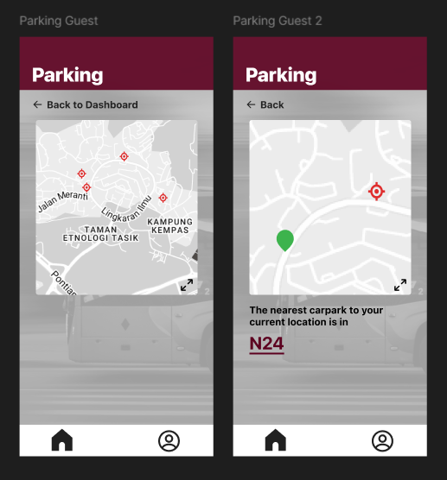

If user chooses Find Lecturer’s Room, user will access shown pages where they can narrow down info to search for accurate lecturer room location.
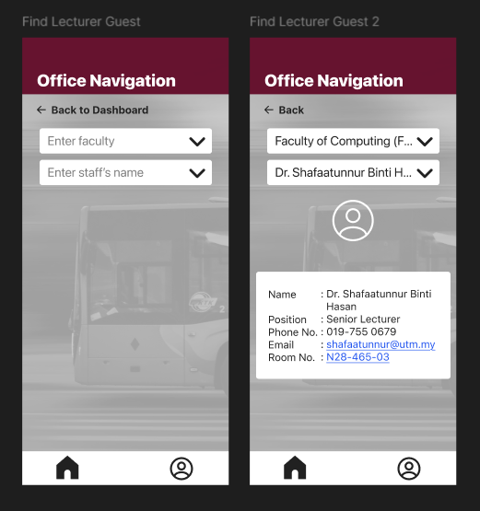

If user chooses Find Block, they will be directed to Find Block page to search for specific college and block location with precise navigation.
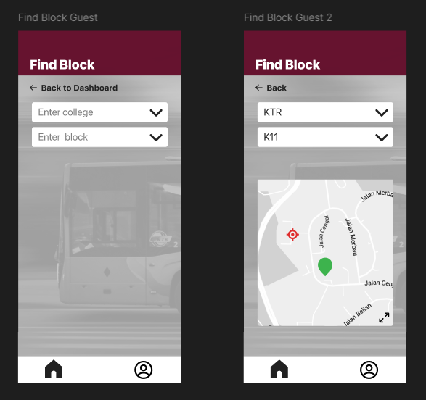

Upon choosing the Visitor Info, user will encounter a page to fill in information as a visitor.
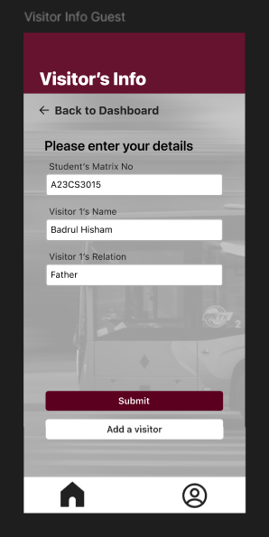

If user chooses to login instead of continuing as Guest, Guest Profile page will appear. User can choose to either go back to Dashboard or logout. If user chooses to logout, they will be redirected to the Login page.
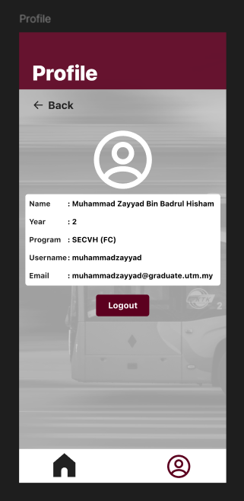

After going back to Dashboard, on the User Dashboard page, user is presented the following options; Shuttle Bus, Parking, Find My Lab, Find Lecturer’s Room, Find Block and Visitor Info.
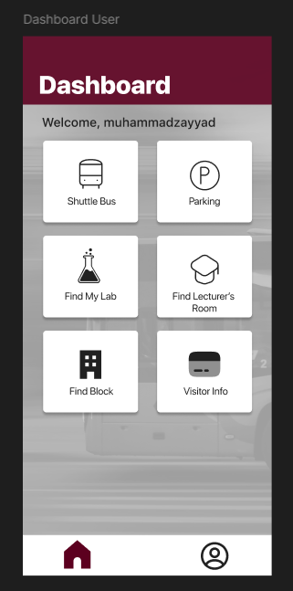

Upon choosing Shuttle Bus, the following pages appear. User can search for a specific bus and look up its live location, along with the departure and arrival times.
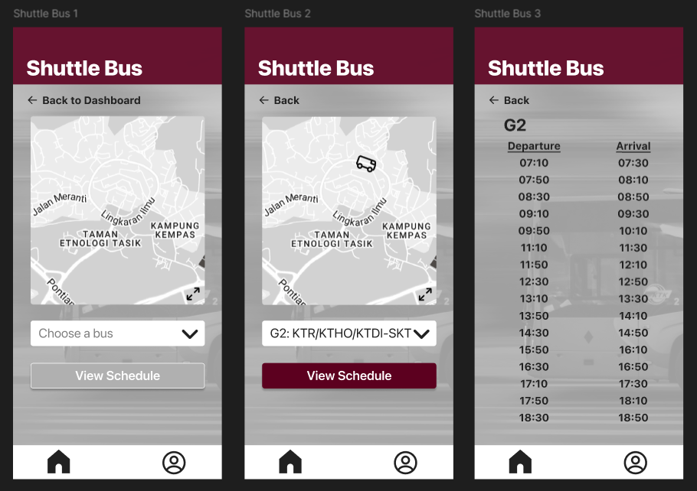

If user chooses Parking, they will encounter the following pages, showing the nearest available parking.
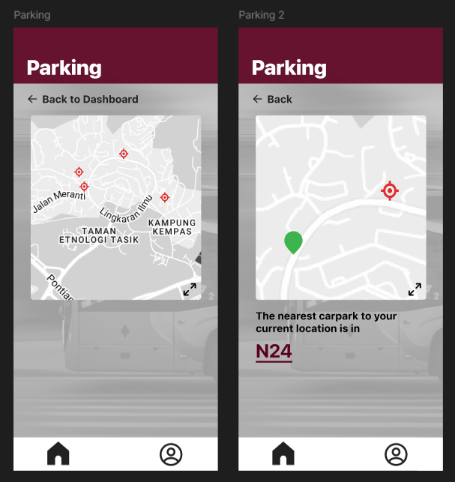

If user chooses Find My Lab, the pages will appear where user can search for and navigate specific laboratory location.
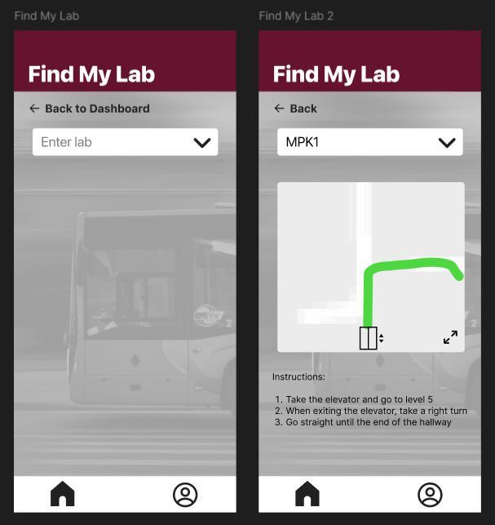

If Find Lecturer’s Room is clicked, user will encounter shown pages to search for and locate any lecturer’s room.
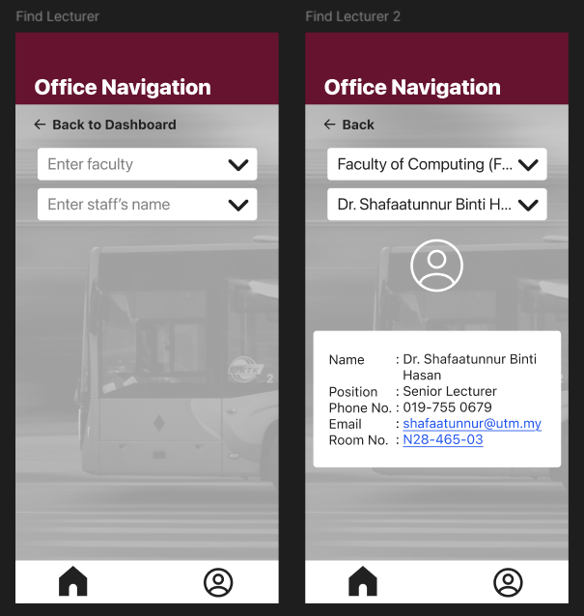

Upon choosing Find Block, user will encounter Find My Block pages as below. User can search for specific college, block and room number, and precisely navigate them.
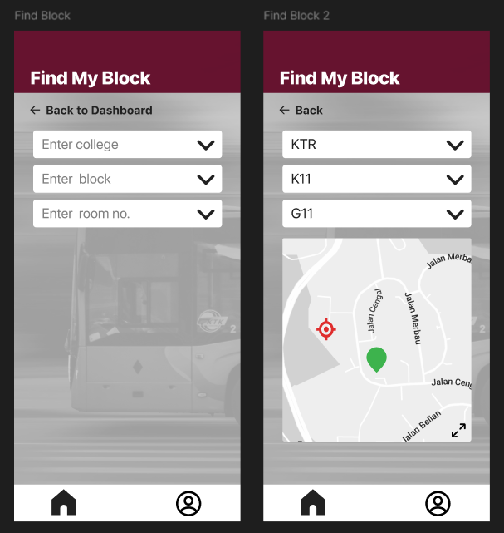

If Visitor Info is chosen, Visitor’s Information will appear as below. A list of visitor(s) is presented, showing the visitor(s) that have filled in information as a visitor for the user on that day.
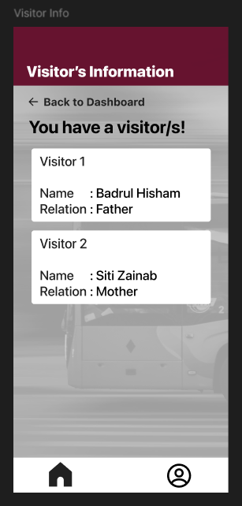

4.5 TEST

The campus navigation app prototype was tested with students and campus visitors to evaluate usability, functionality, and user experience. Testing was based on realistic scenarios, with user interactions observed to identify usability issues and points of confusion. Afterward, participants completed interviews and questionnaires to provide feedback. Overall, users found the prototype highly useful, especially for new students and first-time visitors. They also suggested improvements to route accuracy, real-time data updates, and navigation flow. This feedback was analysed and used to refine the prototype and better meet user needs.

5.0 REFLECTIONS

Upon completing this project, each of our team members have come up with our own reflections concerning goals with regard to our course, how this design thinking impact said goals and improvements necessary to refine our potential in the industry.

WT Nurul Azwa Safira stated, “My goal and dream is to give my very best to complete and understand the task given for this course and enhance my knowledge so that I can implement it in the working era.
This design thinking impacts me through creating something new and allows our design to be recognized through presentation, as our design was what portrays us as a group and as an individual.
To improve my potential in the industry, one of my actions is to continue exploring things that interest me the most and try to learn about them outside of my studies. Focusing only on what has been implemented in the class sometimes will not bring us higher than the potential that we have.”

According to Mohamad Nasrin, “As an aspiring Professional Penetration Tester, I will ensure that I keep up with the threat actors in this industry that has been changing very fast. I will also enhance the digital security of organizations by identifying and exploiting vulnerabilities before they become exploited by hackers and protecting the organization and its critical assets.
Design Thinking has helped me to direct my attention towards using tools rather than simply problem-solving. I can be proactive by thinking like an attacker to expose hidden vulnerabilities by using automated tests. I will continuously stress-test systems and change my approach to eliminate newly emerged security threats.
In order to stay up to date with the industry, I will use practical labs such as Hack The Box and OWASP Juice Shop to master the existing trends. I intend to achieve cybersecurity certification such as CompTIA Security+. I will also keep being informed by subscribing to security researchers and bug bounty write-ups.”

Muhammad Syahmil Amri expressed, “My goal is not just graduating from this course/program with honours but I want build and strengthen my skills and problem solving also build a career in the technology industry where I can make something like developing a practical and impactful solution as technology evolves.
Design thinking does not just help me to focus on what the user really needs. It also shows and trains me how to think more creatively, empathize with users and improvise all my solutions. It helps me to reach my goals and become more professional to step into the industry one day.
I plan to strengthen my fundamentals by joining more on real projects, apart from that i also need to improve my communication skills and also practice design thinking consistently and learn many tools and software and also stay updated with current industry trends.”

As noted by Nuralya Sofea, “My goal is to gain as many knowledge as possible surrounding this course in just these few years, and achieve valuable skills to fully prepare myself to step into the career world.
I view this design thinking as a preparation for myself to relate it to whatever situation, problem or project awaits me in my future career. It helps me learn to create solutions to a difficult problem from scratch, with clear and effective workflow.
To further improve my potential in this industry, I will have to take more initiatives to widen my knowledge relative to the field, instead of just waiting for an opportunity to learn to come straight to me.”

